6.79: In terms of the bumper compression x and the initial speed , the necessary relations are
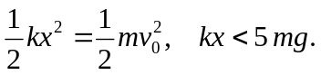
Combining to eliminate k and then x, the two inequalties are
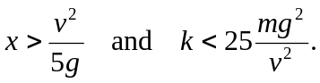
a) Using the given numbers,
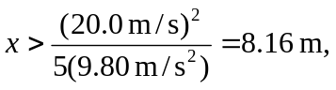
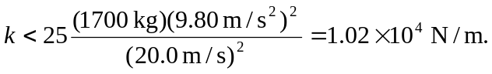
b) A distance of 8 m is not commonly available as space in which to stop a car.

